How To Purchase an Intramural Sports Membership on DSE

- Access DSE and log in with your university credentials: sc.dserec.com
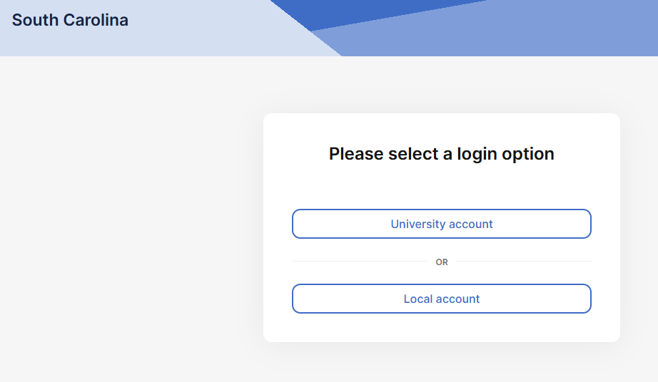
- Go to Memberships
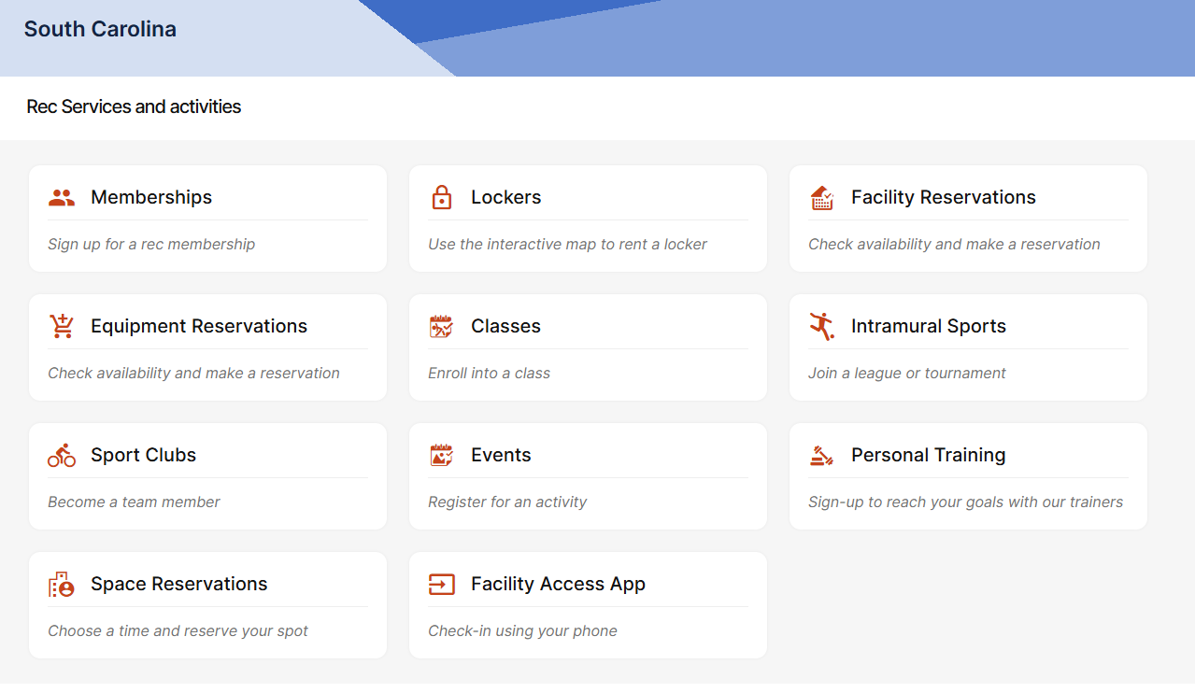
- Purchase the Intramural Sports All-Access Pass (not the Spouse/PlusOne Pass)
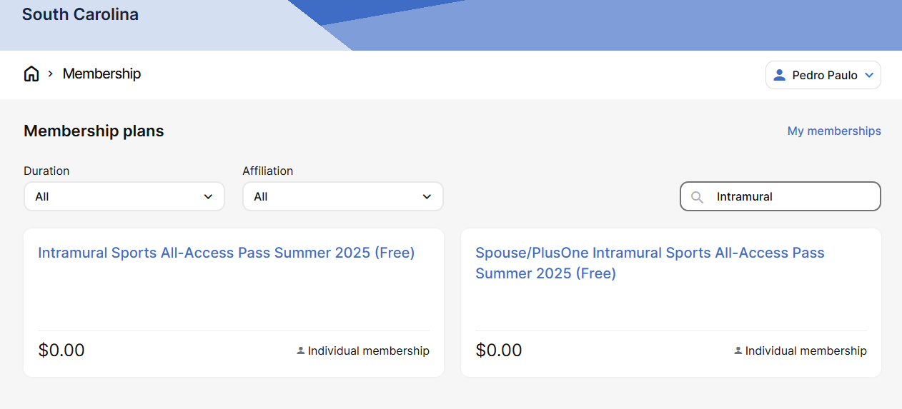
- Create a team or ask that a team captain invites you to theirs. Good luck!

