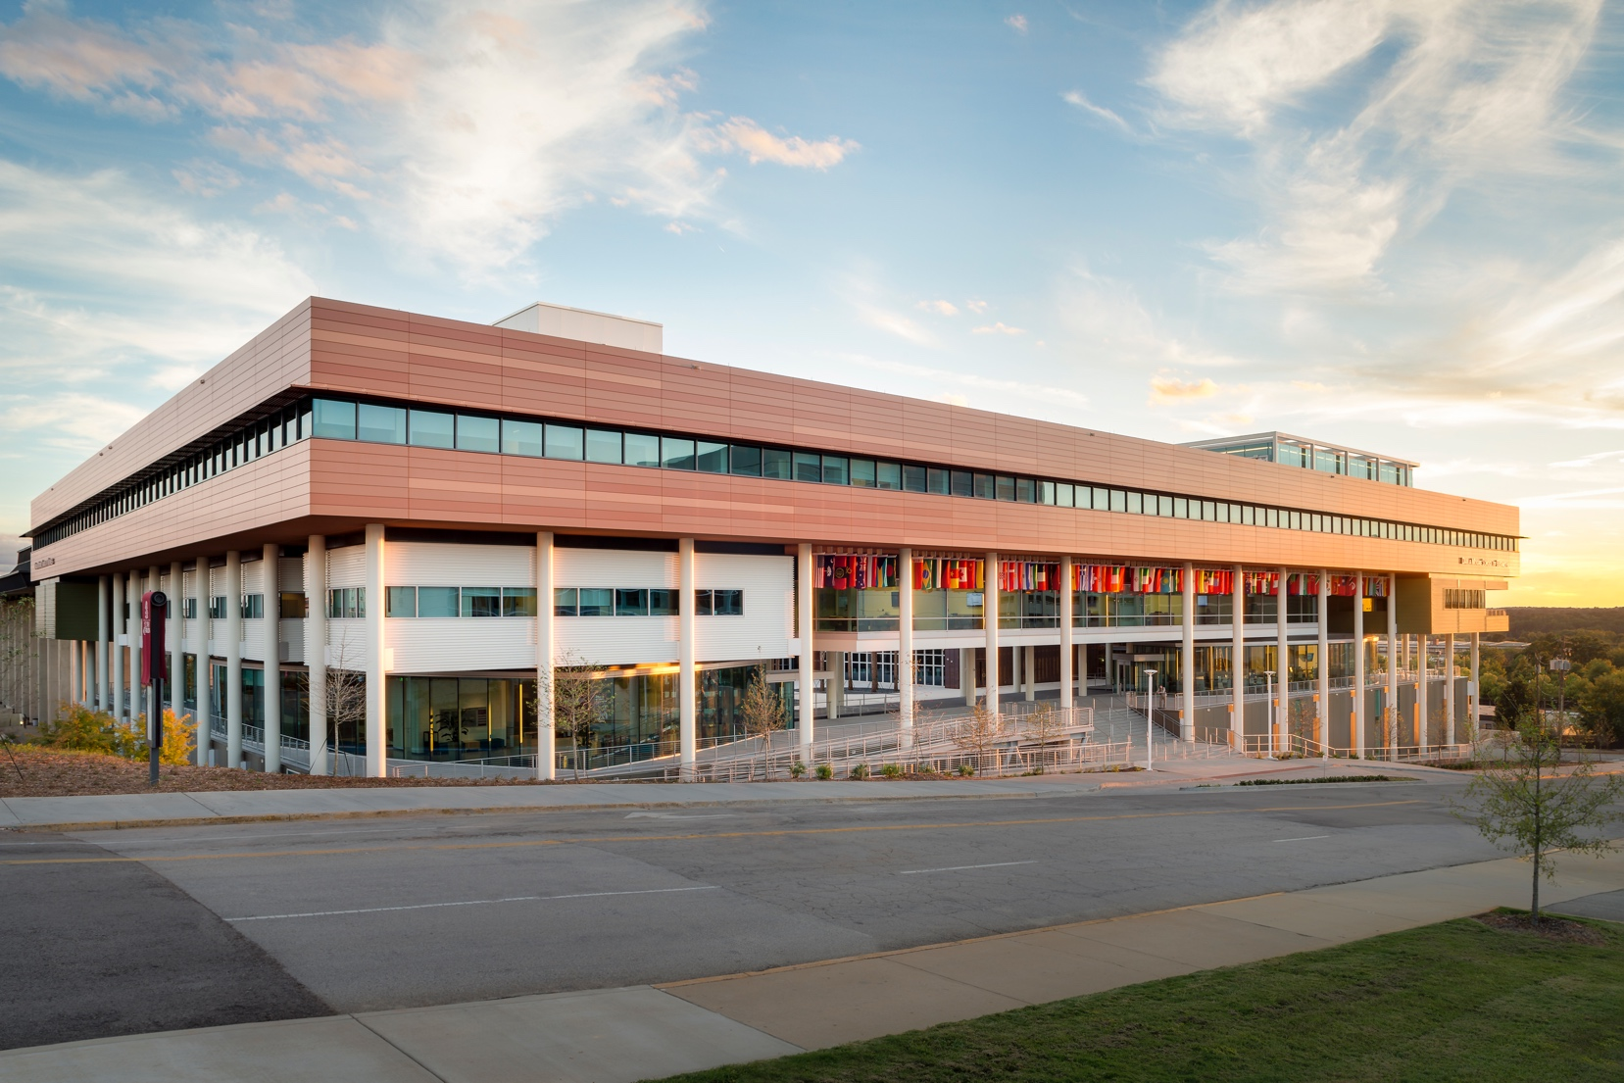


12 p.m. – 1 p.m.
LOCATION HERE
Take a break from finals and enjoy lunch with your cohort and the MBA Student Services team. We’re excited to hear about your first semester and to get to know you better as we bring the summer term to a close.
I/MBA END OF SUMMER SOCIAL
16
WEDNESDAY
AUGUST
SAVE THE DATE

